==================================================

Running Genetic Algorithm...

==================================================

==================================================

=== GENETIC ALGORITHM OPTIMIZATION ===

==================================================

[Initialization]

- Population size: 60

- Generations: 40

- Crossover rate: 80%

- Mutation rate: 20%

- Search space: 16 features

- Target: Minimize MSE using XGBoost

[Evolution Progress]

==================================================

=== OPTIMIZATION RESULTS ===

==================================================

▶ Best MSE achieved: 36362780.000000

▶ Time elapsed: 1226.43 seconds

▶ Features selected: 14/16 (12.5% reduction)

▶ Selected features (with weights):

1. region (weight: 0.771)

2. year (weight: 0.574)

3. manufacturer (weight: 0.867)

4. model (weight: 0.788)

5. condition (weight: 0.797)

6. cylinders (weight: 0.778)

7. fuel (weight: 0.796)

8. odometer (weight: 0.772)

9. drive (weight: 0.607)

10. type (weight: 0.585)

11. paint_color (weight: 1.000)

12. state (weight: 0.789)

13. lat (weight: 0.888)

14. long (weight: 1.000)

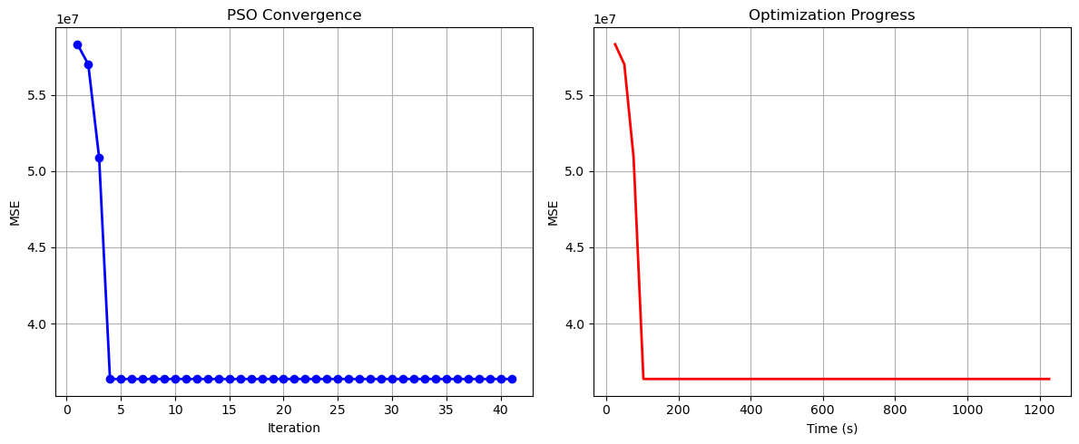

Particle Swarm Optimization completed successfully with MSE: 36362780.0000

==================================================

Running Whale Optimization...

==================================================

==================================================

=== WHALE OPTIMIZATION ALGORITHM ===

==================================================

[Initialization]

- Population: 60 whales

- Max iterations: 40

- Spiral coefficient (b): 1.0

- Search space: 16 features

- Target: Minimize MSE using XGBoost

[Optimization Progress]

Iter 40/40 | Best MSE: 36735324.000000

==================================================

=== OPTIMIZATION RESULTS ===

==================================================

▶ Best MSE achieved: 36735324.000000

▶ Time elapsed: 1197.04 seconds

▶ Features selected: 15/16 (6.2% reduction)

▶ Selected features:

1. year

2. manufacturer

3. model

4. condition

5. cylinders

6. fuel

7. odometer

8. title_status

9. transmission

10. drive

11. type

12. paint_color

13. state

14. lat

15. long

▶ Convergence progress:

- Initial MSE: 97241848.0000

- Final MSE: 36735324.0000

- Improvement: 62.2%

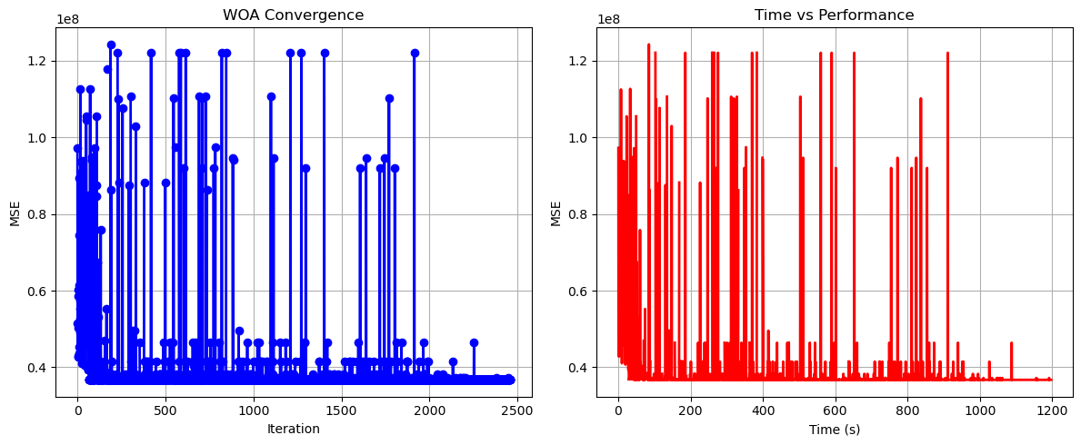

Whale Optimization completed successfully with MSE: 36735324.0000

==================================================

Running Squid Game Optimizer...

==================================================

==================================================

=== SQUID GAME OPTIMIZER (SGO) ===

==================================================

[Initialization]

- Players: 60 (30 offensive, 30 defensive)

- Max games: 40

- Search space: 16 features

- Target: Minimize MSE using XGBoost

==================================================

=== OPTIMIZATION RESULTS ===

==================================================

▶ Best MSE achieved: 36336712.000000

▶ Time elapsed: 1155.68 seconds

▶ Features selected: 13/16 (18.8% reduction)

▶ Selected features:

1. year

2. manufacturer

3. model

4. condition

5. cylinders

6. fuel

7. odometer

8. transmission

9. drive

10. type

11. paint_color

12. lat

13. long

▶ Convergence progress:

- Initial MSE: 40650688.0000

- Final MSE: 36336712.0000

- Improvement: 10.6%

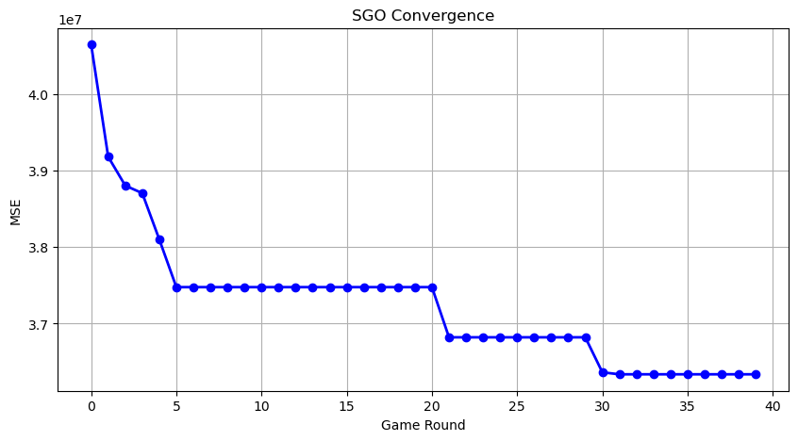

Squid Game Optimizer completed successfully with MSE: 36336712.0000

==================================================

Running PSH-Hyptrite...

==================================================

==================================================

=== PSH-HYPTRITE OPTIMIZATION ===

==================================================

[Initialization]

- Search points: 60

- Max iterations: 40

- Initial radius: 0.5 (adaptive)

- Hypersphere samples: 3 per point

- Search space: 16 features

- Target: Minimize MSE using XGBoost

[Optimization Progress]

Iter 40/40 | Best MSE: 36336712.000000 | Radius: 0.0125

==================================================

=== OPTIMIZATION RESULTS ===

==================================================

▶ Best MSE achieved: 36336712.000000

▶ Time elapsed: 3508.74 seconds

▶ Features selected: 13/16 (18.8% reduction)

▶ Selected features (with weights):

1. year (weight: 0.973)

2. manufacturer (weight: 0.885)

3. model (weight: 0.546)

4. condition (weight: 1.000)

5. cylinders (weight: 1.000)

6. fuel (weight: 0.706)

7. odometer (weight: 0.671)

8. transmission (weight: 0.780)

9. drive (weight: 0.662)

10. type (weight: 0.789)

11. paint_color (weight: 0.887)

12. lat (weight: 0.810)

13. long (weight: 0.950)

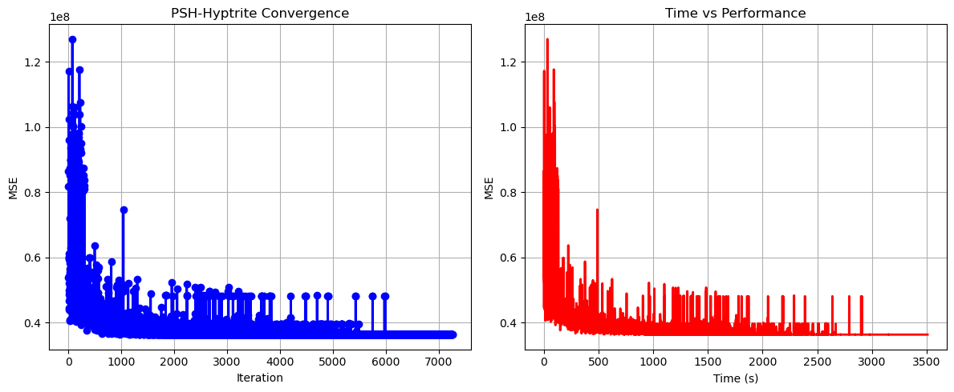

PSH-Hyptrite completed successfully with MSE: 36336712.0000

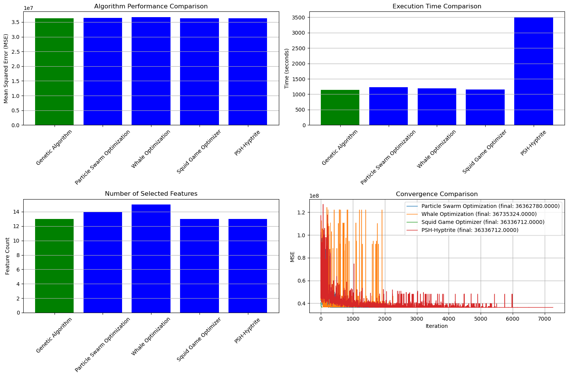

==================================================

FINAL RESULTS SUMMARY

==================================================

🏆 Best Algorithm: Genetic Algorithm

📉 Best MSE Achieved: 36336712.000000

⏱️ Execution Time: 1145.63 seconds

🔢 Features Selected: 13

Selected Features:

1. year

2. manufacturer

3. model

4. condition

5. cylinders

6. fuel

7. odometer

8. transmission

9. drive

10. type

11. paint_color

12. lat

13. long